DANIEL CN

192211044

CLASS DIAGRAMS

1.VOTING SYSTEM:

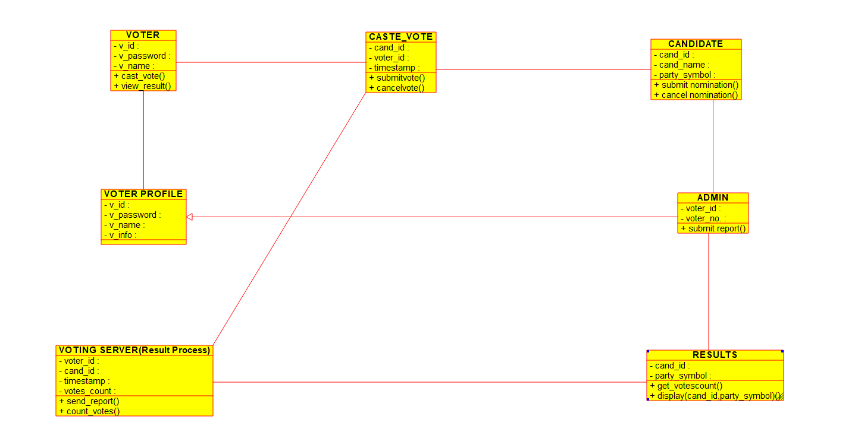

2.ONLINE SHOPPING:

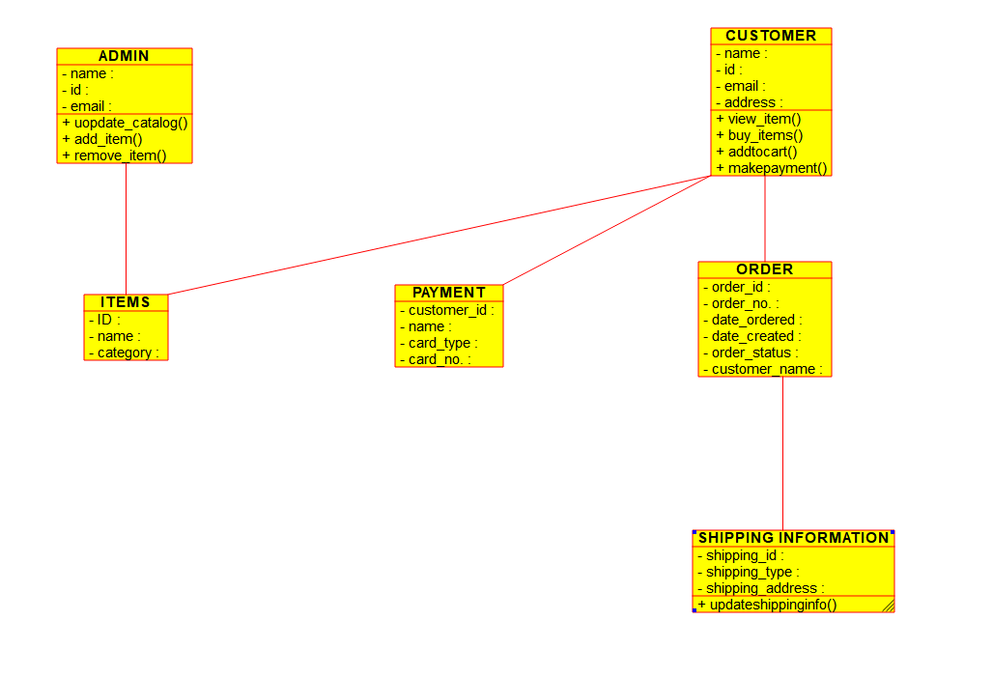

3.LIBRARY MANAGEMENT:

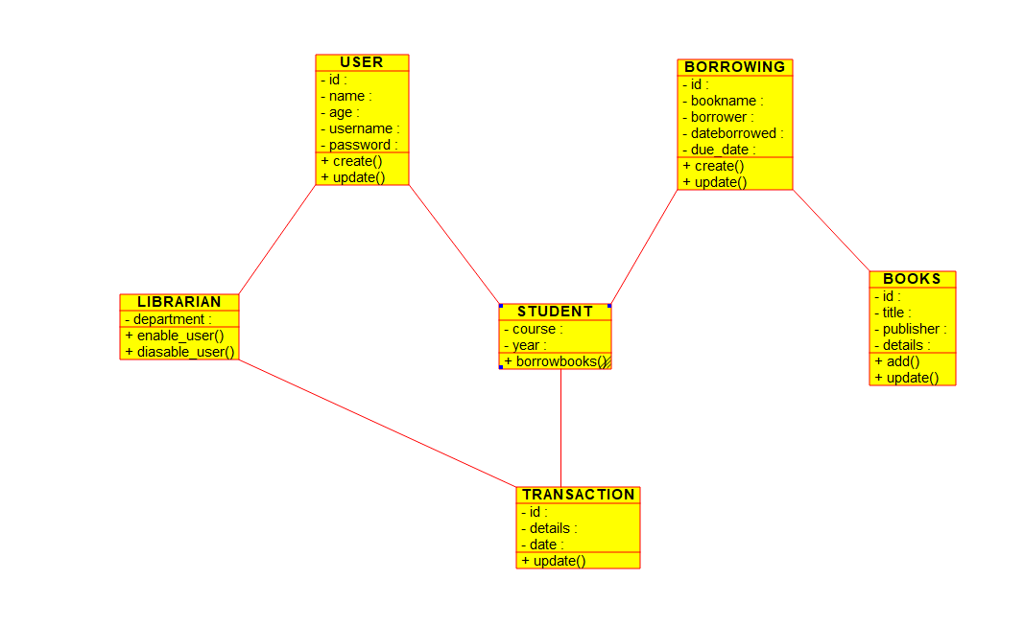

4.RAILWAY RESERVATION:

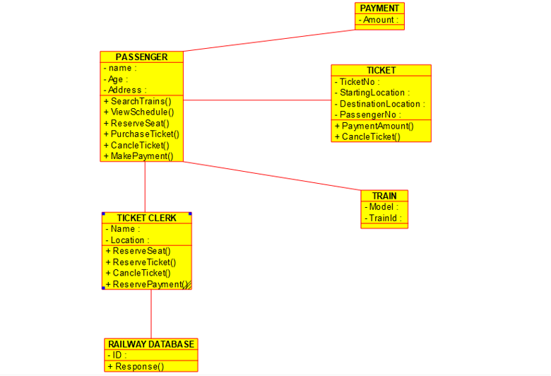

5.AIRLINE RESERVATION:

